**Create FREE Microsoft Azure Trial Account**

We will cover Steps by Step guide on how to register For FREE Microsoft Azure Cloud Trial Account.

We will use this FREE Microsoft Azure trial account in the future for Azure Resources like Compute, Networking, Storage, Database, Web Services and etc.

Key Points:

1. You should have a Credit Card, an email address and phone number.
2. If you don’t have a Credit Card, you can register [here](https://azure.microsoft.com/en-in/free/students/) using a valid student college email id.

Steps To Register For FREE Azure Cloud Trial Account

1. Go to the[Azure Home Page](https://azure.microsoft.com/en-us/).

2. Click on Free Account on the top right corner.



3. Click on Start Free.

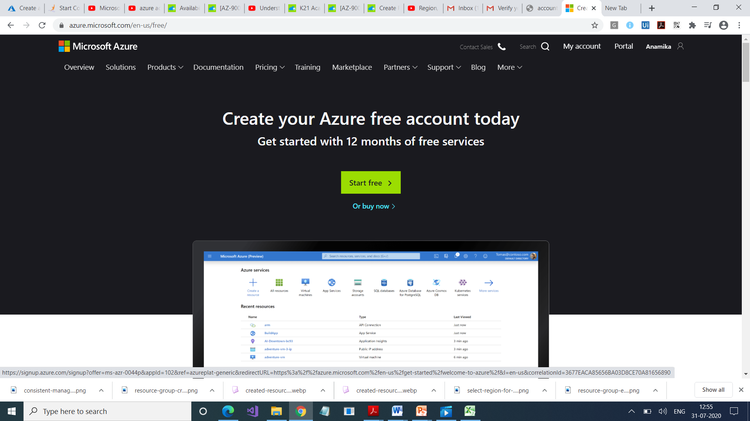

4. Sign-in/Sign-up for a Microsoft account using an email address and password.

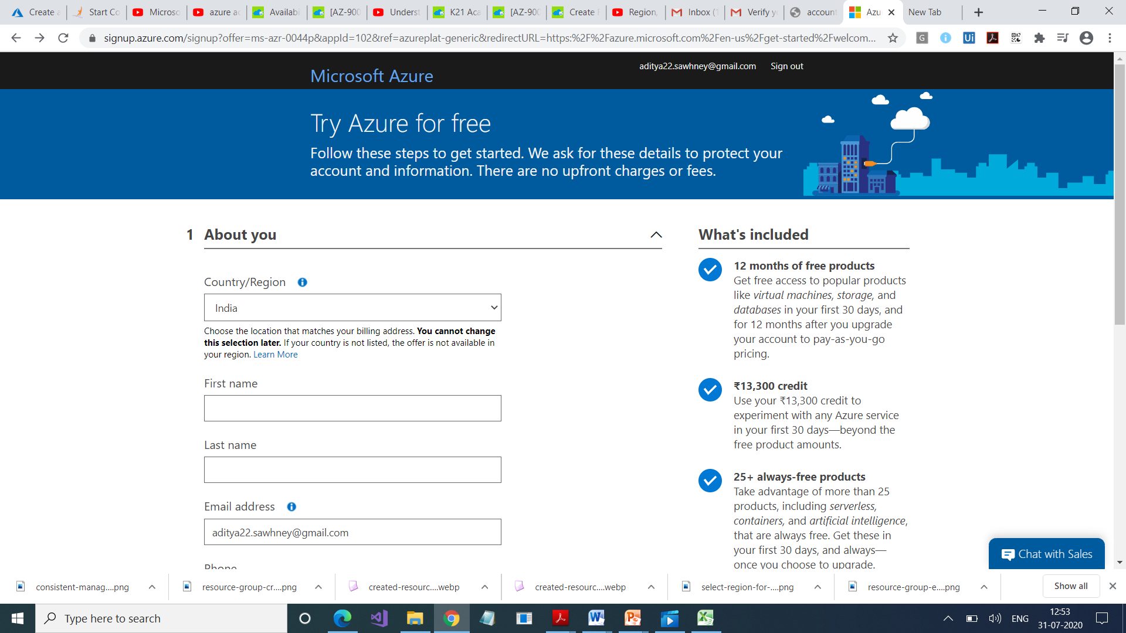

5. Enter your Country/Region and Date of Birth and click next.

6. Enter the verification code received on the email address and click next.

7. Type the captcha you see on your screen and click on next.

8. You’ll be redirected to the Azure Sign-up page. Enter your Region, Name, Phone number, Email address. Note: You should use the same email address for Azure sign-up and for Microsoft account.

9. Verify your phone number by clicking Text Me or Call Me and enter the verification code received.

10. Enter the payment details. Make sure you have a Master Card/American Express/ Visa Credit card and international payments should be enabled.

11. Check the Terms and Conditions and click Sign-up.

12. You have successfully created an Azure trial account and now have a lumpsum balance of $200.

13. Click on Portal on the top right corner of the screen. You’ll be redirected to the Azure portal.

*Note: If you are a student and don’t have a credit card, then you can also*[*register*](https://azure.microsoft.com/en-in/free/students/)*using your student ID.*